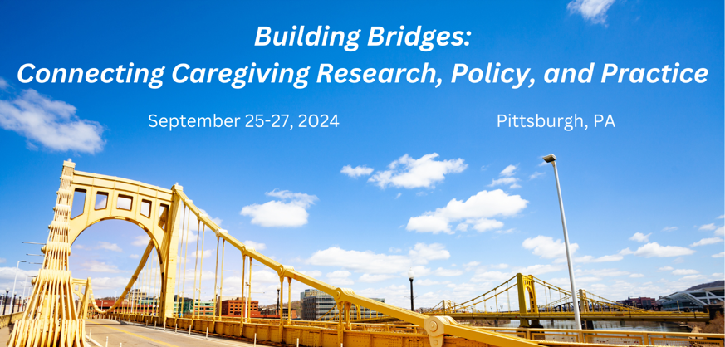

Secondary Data Analysis Training Workshop

Friday, September 27, 2024 from 12-5 PM ET
Pittsburgh, PA

The inaugural secondary data analysis training workshop is an immersive, no-cost opportunity for early career researchers in caregiving to gain skills in the use of national datasets for secondary data analyses to advance science, policy, and practice. During the half-day workshop, experts will provide an overview of caregiving datasets and work directly with early career researchers to develop an analytic plan to move towards a publication. Twelve applicants will be selected for this exclusive experience.

Advance Your Career and the Future of Caregiving Research

Gain knowledge of national datasets and analytic techniques | Make connections with leaders and peers in the caregiving field | Develop an analytic plan for a secondary data analysis

Schedule
Time | Activity
12:00-12:15p | Welcome, introductions, and overview of workshop
12:15-12:30p | Overview of the National Health and Aging Trends Study and the National Study of Caregiving (NHATS/NSOC)
12:30-12:45p | Example NHATS/NSOC secondary data analytic plan
12:45-1:00p | Overview of the Behavioral Risk Factor Surveillance System (BRFSS)
1:00-1:30p | Example of BRFSS secondary data analytic plan
1:30-1:45p | Overview of the National Survey of Children’s Health (NSCH)
1:45-2:00p | Example NSCH secondary data analytic plan
1:45-2:00p | Break
2:00-4:00p | Small group worktime with expert mentors on selected datasets
4:00-4:50p | Small group report out and whole group discussion
4:50-5:00p | Closing and training evaluation

Meet the Mentors
Dr. Scott Beach, PhD is the Director of Survey Research at the Center for Social & Urban Research at the University of Pittsburgh. His research interests include areas such as aging and caregiving stress, elder abuse, and technology. Dr. Beach will serve as a primary mentor for applicants who choose to learn more about the NHATS/NSOC.

Dr. Kate Perepezko, PhD, MSPH is a Postdoctoral Associate at the National Center on Family Support at the University of Pittsburgh. Her research interests include dyadic research methods, successful aging, and goal setting. Dr. Perepezko will serve as a secondary mentor for applicants who choose to learn more about the NHATS/NSOC.

Dr. Erin Kent, PhD is an Associate Professor and Associate Chair of the Department of Health Policy and Management at the UNC Chapel Hill. Her research interests include areas such as cancer survivorship, cancer caregiving, palliative care, and social determinants of health. Dr. Kent will serve as a primary mentor for applicants who choose to learn more about the BRFSS.

Dr. Kelly Tan, PhD, RN is an Assistant Professor in the School of Nursing at the University of Pittsburgh. Her research interests include health equity, cancer, caregiving, and positive psychology. Dr. Tan will serve as a secondary mentor for applicants who choose to learn more about the BRFSS.

Dr. Justin Yu, MD, MS is an Assistant Professor of Pediatrics at the University of Pittsburgh. His research interests include pediatric palliative care, family caregiving, and children with medical complexity. Dr. Yu will serve as a primary mentor for applicants who choose to learn more about the NSCH.

Kevin Huynh, MS is a 3rd year medical student at the University of Pittsburgh. His research interests include palliative care, family caregiving, and children with medical complexity. Mr. Huynh will serve as a secondary mentor for applicants who choose to learn more about the NSCH.

Who Should Apply
Applications will be reviewed from early career researchers (PhD students, postdoctoral fellows, junior faculty). Applicants should be interested in pursuing caregiving research projects using secondary data and collaborating with a team of early career researchers. Applicants must be affiliated with a research university or organization. Applications are encouraged from researchers from diverse backgrounds, including individuals from underrepresented racial and ethnic groups, individuals with disabilities, individuals from disadvantaged backgrounds, individuals who identify as lesbian, gay, bisexual, asexual, transgender, Two-Spirit, queer, and/or intersex, and women.

How to Apply
Please see the application form on the following pages. It will include:
- General applicant information.
- Applicants must rank their preference for working with three national datasets (NHATS/NSOC, BRFSS, or NSCH) linked in schedule above.
- Statement of 200 words or less describing the applicant’s objectives for attending the workshop, interest in working with a national dataset, and how the training would help them in their career/research.
- NIH biographical sketch (general).
- Letter of recommendation from someone familiar with the applicant’s professional interests and scholastic achievements, including their ability to complete and publish findings from a secondary data analysis using a national dataset.

All application materials should be combined into one PDF file and e-mailed to caregivingconference@pitt.edu by the application deadline: May 17, 2024 at 11:59 PM ET. Twelve applicants (4 per dataset group) will be selected for this competitive training and must be registered for the Biennial Caregiving Conference . Expenses for the workshop, working lunch, and course materials will be covered. A limited number of travel scholarships may be available. Applicants will be notified of decision by May 31, 2024.

Application Evaluation Criteria
Applications will be reviewed by the Workshop Convening Committee, comprised of caregiving researchers from across the country. Applicant’s will be evaluated based on the following criteria:
- Previous statistical experience and conducting secondary data analyses.
- Letter of recommendation.
- Alignment of stated objectives with the goals of the workshop.
- Demonstrated interest in caregiving research using secondary data.

Please reach out to caregivingconference@pitt.edu with any questions.

APPLICATION QUESTIONS ON NEXT PAGE

APPLICATION

Name:______________________________________________________________________________

Title:________________________________________________________________________________

Highest Terminal Degree: ____________________________________________________________

Current Position: ____________________________________________________________________

Department: ________________________________________________________________________

Institution/Organization: _____________________________________________________________

Research Interests: __________________________________________________________________

Are you interested in being considered for a travel scholarship?

Yes

No

If you would like to be considered for a travel scholarship, please provide a 1-3 sentence statement of financial need.

How familiar are you with conducting secondary data analyses?

Not at all familiar Somewhat familiar Moderately familiar Very familiar

How frequently do you work with national datasets?

Never Occasionally A moderate amount A great deal

Please rank your preference for working with the selected datasets (1, 2, and 3):

NHATS/NSOC

BRFSS

NSCH

Please attach your statement of 200 words or less below.

Please attach your NIH-formatted biographical sketch below.

Please attach your letter of recommendation.

